**Tutorial Using GIT-LAB**

# Init Gitlab

1. Create new directory  
   Graphical user interface

   Description automatically generated
2. Open Git Bash Here

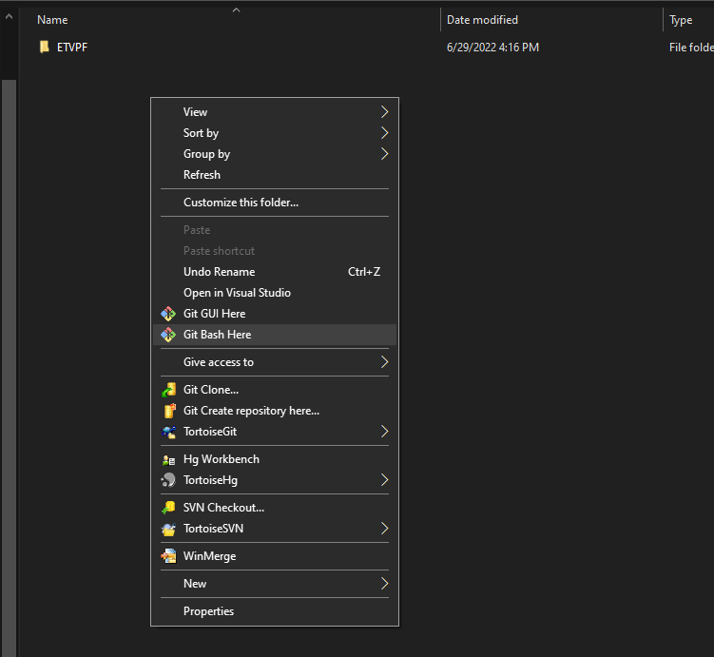

1. Change the username and email global in gitbash

Figure 1 Check info in GITLAB

git config --global user.name "<username in GITLAB>"

git config --global user.email "<your.email@renesas.com>"

1. Disable SSL verification globally while running the git clone.

git config --global http.sslVerify false

1. Get the HTTPS on GITLAB sever  
   Graphical user interface, text, application, email

   Description automatically generated

Figure 2 Check HTTPS git

1. Using git clone to clone the project  
   git clone “HTTPS” – After using git clone, some users will popup the login account, Enter the account from GITLAB   
   A screenshot of a computer

   Description automatically generated

Figure 3 Check Git Clone Success

1. …

# How to update

* Go to directory you want to update -> Open Git Bash Here  
  Graphical user interface

  Description automatically generated
* Use command “git pull” to pull new source code

# How to commit

* Refer part “I How to update” for update to new revision
* Use “git status” to see which file have been edit (In picture I modify callback_about.m and add new source callback_about_new.m)

* Using “git add ‘file’ ” – You can add separate each file or add full with command “git add -A”

* When “git status” is green it’s mean you complete add it into git
* Use git commit -m "commit message"

* After commit success, using “git push” to push the commit into sever

# How to check revision history

* Using “git log” to check revision

* If you want to check previous revision “git log -1”

* Exit in “git log” press “q”

# How to revert to revision history

* Using git log in chapter III, and remember the revision you want to revert like the red draw bellow

* You have 2 option in this part:  
  1. You want check out new revision into new branch not impact old branch => Using “git checkout revision” => Your current working in revision a37df62517911d5a594afa1f25cc9df84edb7bd6 and in another branch, not impact main branch

2. You want to revert into revision xxx and in main branch, using “git revert xxx” - xxx is revision => This way is very rick because when you revert it will cause conflict unless you have solution for conflict file

=> I prefer the option 1 checkout to new branch to do anything you want, then you commit it into main branch

# How to move to another branch

1. Git branch -> check your current branch on repo

1. Git branch -a -> check all branch exist in repo

1. Git checkout branch name -> move to branch

# How to merge branch

T.B.D

# Reset git when your git error

If your git is error, doing following command:  
- Copy your modify or important file on your git out into another location (Backup file before reset git)

* Execute command “Git clean -d -f” to clean all file which not exist on git sever
* Execute command “Git reset --hard” to reset git into current revision
* Execute command “Git pull origin” to push new revision on git